2. What is an expansion slot? Explain its types?

**Table 1: Logic gate symbols**

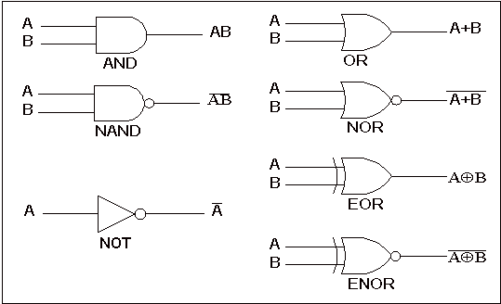

The summary of truth table of the input/output combinations for the NOT gate together with all possible input/output combinations for the other gates. A Truth Table with 'n' inputs has 2n rows. **Logic gates representation using the Truth table**

